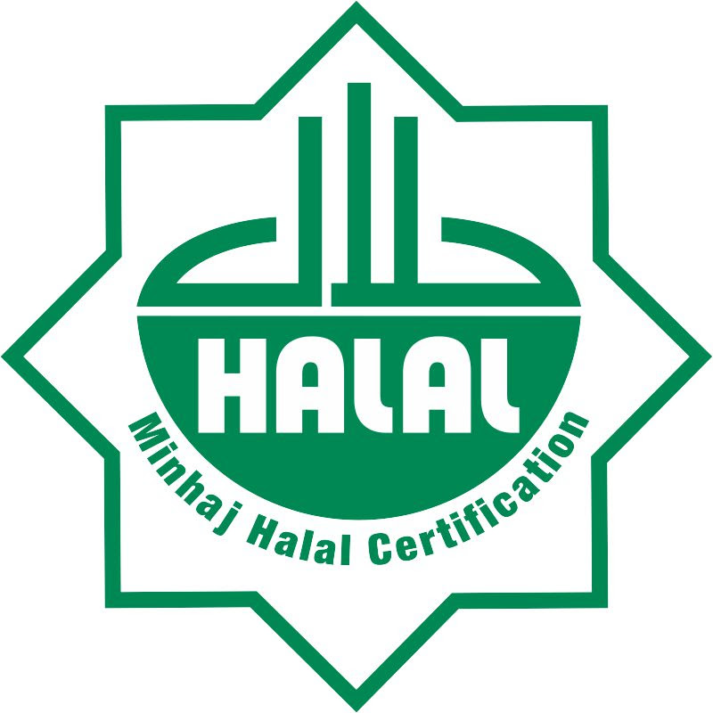

Minhaj Halal Certification

" O mankind! Eat of that which is lawful and pure in the Earth".al-Baqarah, 2:168

APPLICATION FORM

Minhaj Halal Certification Pvt. Ltd

Minhaj Halal Certification Pvt. Ltd
Minhaj ul Quran University Road, Township, Lahore
Phone: 042-35142024
Website: www.minhajhalal.com Email: info@minhajhalal.com

Minhaj Halal Certification

“O mankind! Eat of that which is lawful and pure in the Earth".Al-Baqarah, 2:168

Application Form for Halal Certification

1. Company/Business Name: _____________________________________________________________
2. Business Status (CMC, Corporation, Pvt. or Trust etc.):______________________________________
3. Registration No.: __________________ Registered by_______________________________________
4. List of Products/Brands (use Annexure I)
5. Product/Brand to be certified: __________________________________________________________
6. Registered Office Address: ____________________________________________________________
7. Physical Address:____________________________________________________________________
i) Postal Code___________ ii) Tel: ________________________ iii) Fax: ________________________
iv) E-Mail: _________________________ v) Website: _______________________________________
8. Plant Address: ______________________________________________________________________
i) Postal Code___________ ii) Tel: ________________________ iii) Fax: ________________________
9. Correspondence Person: _______________________________________________________________
Designation: __________________________________________________________________________
i) Address: ______________________________________ ii) Postal Code_________________________
iii) Tel: ____________________________ iv) Fax: ___________________________________________
v) Cell: ____________________________ vi) E-Mail: ________________________________________
10. Kindly enclose a complete list of raw material, together with supplier; manufacturer; telephone; fax; email; contact person details in the attached format: (Find Annexure II)

11. Describe a brief History of Supply Chain of Ingredients/Raw Materials:

____________________________________________________________________________________
____________________________________________________________________________________
____________________________________________________________________________________
____________________________________________________________________________________
12. Briefly describe logistics of the Product: ____________________________________________________________________________________
____________________________________________________________________________________
____________________________________________________________________________________
____________________________________________________________________________________

I/we undertake that the information provided by us for Halal Certification is based on real practices. All the ingredients/Raw Materials are mentioned truly in the application/annexure (being used in the formulation). We also undertake that we will prior inform to the MHC if any change occur in the formulation hereafter.

Applicant Name: ______________________________________________________________
Designation: ________________________________________________________________________
Signature: __________________________________________________________________________
Company Seal & Stamp: ______________________________________________________________
Date: ______________________________________________________________________________

Confidentiality Statement:
MHC, however, undertakes that it will guarantee all information supplied by or obtained from the application in respect to its processes, business secrets, prices and operations in the strictest confidence and it will not leak such information for the benefit of any other person or company.
For Office Use only:
Date of Receiving: __________________ Date of Approval for Certification: ___________________
File No.__________________________ Signature: ______________________________________

Note: Kindly ensure prior facilitation on the following items:
- Kindly endorse the application with company rubber stamp only
- Please return completely filled application form together with the required full disclosures through email (info@minhajhalal.com) post or fax to MHC Office.
- A cover letter is mandatory to be submitted on the official company letterhead be also submitted outlining the following:
A. Brief Company Profile.
B. Registration and Certifications Details.
C: Brief Description of Product Process Flow (use annexure III)
D. Geographical Business Targeted Area (use annexure IV)
E. Any other relevant info which will be useful for Certification Process.
- Application forms will only be accepted when fully completed and duly signed by the Proprietor /Director or authorized representative. Failure to adhere to the above guidelines may delay the processing of your application.
- 50% certification fee will be charged in advance at the time of the contract submission.

Annexure I
List of Products/Brands
No. | Brand/Product Name | Description | Major Ingredients to be used
1.

2.

3.

4.

5.

6.

7.

8.

9.

10.

Annexure II
List of Raw Materials, Together With Supplier/Manufacturer
No. | Ingredients/Raw Material | Code | Supplier | Supplier  Contact Details | Manufacture  (if different from supplier) | Either Supplier/ Manufacture  Providing Halal certified  Ingredients/Raw Material
1. |  |  |  | Contact person:  Address:  Phone:  Fax:  Email:  Website: | Contact person:  Address:  Phone:  Fax:  Email:  Website: | - Yes  - No
2. |  |  |  | Contact person:  Address:  Phone:  Fax:  Email:  Website: | Contact person:  Address:  Phone:  Fax:  Email:  Website: | - Yes  - No

3. |  |  |  | Contact person:  Address:  Phone:  Fax:  Email:  Website: | Contact person:  Address:  Phone:  Fax:  Email:  Website: | - Yes  - No
4. |  |  |  | Contact person:  Address:  Phone:  Fax:  Email:  Website: | Contact person:  Address:  Phone:  Fax:  Email:  Website: | - Yes  - No
5. |  |  |  | Contact person:  Address:  Phone:  Fax:  Email:  Website: | Contact person:  Address:  Phone:  Fax:  Email:  Website: | - Yes  - No

Annexure III

Brief Description of Product Process Flow

Annexure IV

Geographical Business Targeted Area

Production Summary
Local Contribution %___________________________
Export Contribution %___________________________

Local Break Up
- Sindh %__________________________
- Punjab %___________________________
- Balochistan %___________________________
- Khyber Pakhtunkhwa %___________________________

Export Break Up
- Asia %___________________________
- Europe %___________________________
- Australia %___________________________
- Africa %___________________________
- Americas %___________________________

Countries name where you export significantly
No. | Country Name | Export %
1.
2.
3.
4.
5.

Disclaimer:-
Aforementioned information will be utilized with strict confidentially to evaluate your geographical presence to facilitate and explore new horizons of markets. Thank you.

